

**Parents’ Guide for *Times Tables Rock Stars***

# Logging in

1. Log onto the website by clicking this link: [https://play.ttrockstars.com/auth/school/student.](https://play.ttrockstars.com/auth/school/student)
2. Begin typing **Grange Park Junior School** and then select the school.

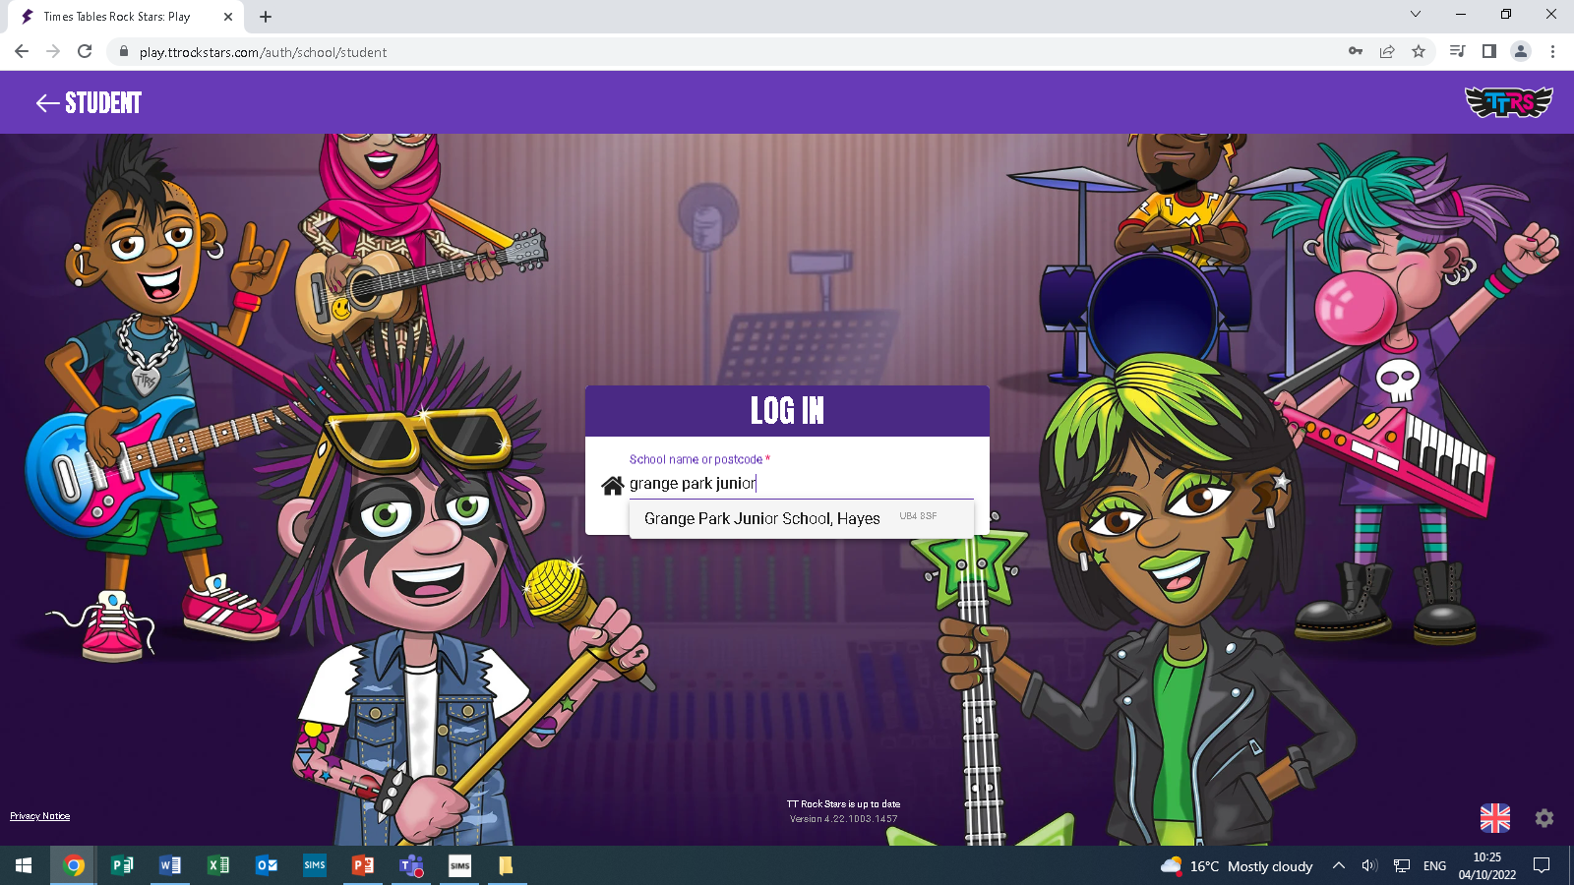

1. Enter the **Username** and **Password** *or* **Pin** sent home by the class teacher (in the back of your child’s reading record) and click **Log In**.

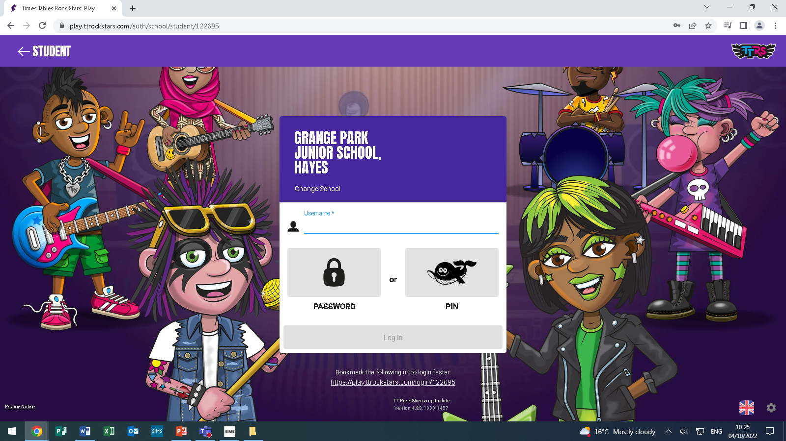

1. Select the Game mode (see below).

# What are the different game modes?

Your child can play independently, or in friendly competitions against their friends, other classes and even other children around the world! Your child will begin by creating their own avatar so that their identity remains anonymous.

|  |  |
| --- | --- |
| **Single Player** | |
| **Garage**  10 coins per correct answer | Players answer the tables selected by *Times Tables Rocks Stars*’ Auto trainer.  Your child will practise the one table chosen for them in small chunks of 4 questions at a time. The algorithm selects the table after a Gig game. |
| **Gig**  10 coins per correct answer | Your child will periodically play Gig games to assess which table is best for them to practise in the Garage.  **Important**: players must give each Gig performance their full concentration to demonstrate their tables skills. They may be returned to an earlier table if not. |
| **Jamming**  4 or 8 coins/correct answer | The only game mode without a timer, your child choses the table and the operation (× or ÷ or both) they want to practise. Answer 10, 20 or 30 questions. |
| **Studio**  1 coin per correct answer | Here your child earns their Rock Status, which is based on their Studio Speed. The faster they are the better their status. Studio Speed is the average of their most recent 10 Studio games. Suitable for confident players. |
| **Soundcheck**  5 coins per correct answer | Soundcheck games ask 25 multiplication questions (up to 12×12), allowing 6 seconds for each question. Suitable for confident players. |
| **Multi Player** |  |
| **Festival**  1 coin per correct answer | Your child can compete against others from around the world, with their identities protected behind their rock names. Suitable for confident players. |
| **Arena**  1 coin per correct answer | Your child can race against other members of their class who are logged in and choose the same arena name at the same time. Like Garage, Arena games ask questions that are set by Times Tables Rock Stars’ Auto trainer. |
| **Rock Slam**  1 coin per correct answer | Players challenge their classmates or teachers to answer as many questions as they can in 60 seconds, setting a score for the challenge to beat. Pupils don’t need to be online at the same time. |
| **Tournaments** | Battle of the Bands – groups of children within the same school (usually classes, year groups or teams) compete to have the highest average score per player.  **Important**: Each correct answer (in any game mode) earns 1 point towards the team’s total in addition to the coins earned. For example, in Garage games each correct answer is worth 1 point for the team and 10 coins for the player. |
| Top of the Rocks – think of this as a Battle of the Bands *between* schools. The winning class or school is the one with the most correct answers per person. Players’ identities are always protected behind their “Rock Names.” |

***Rock Status***

Your child’s *Rock Status* is determined by the number of questions answered correctly during a session:

|  |  |
| --- | --- |
| **№ correct answers** | ***Rock Status*** |
| < 5 | Wannabe |
| 6 | Garage Rocker |
| 7 | Busker |
| 8 | Gigger |
| 9 | Unsigned Act |
| 10-11 | Breakthrough Artist |
| 12-14 | Support Act |
| 15-19 | Headliner |
| 20-29 | Rock Star |
| 30-59 | Rock Legend |
| 60+ | Rock Hero |

# Which times tables should we be practising?

The table below is a guide to which times tables children should know by the end of their respective school year:

|  |  |
| --- | --- |
| **Year group end** | **Times tables** |
| End of year 1 | 2s. 5s and 10s |
| End of year 2 | 2s, 3s, 5s and 10s |
| End of year 3 | 2s, 3s, 4s, 5s, 8s and 10s |
| End of year 4 | 2s, 3s, 4s, 5s, 6s, 7s, 8s, 9s, 10s, 11s and 12s |

# Learners with different needs

*Times Tables Rock Stars* has multiple functionalities to ensure accessibility for children of different levels of learning. Below are some suggestions as to how *Times Tables Rock Stars* can be modified to help support your child’s learning.

|  |  |
| --- | --- |
| **How can I hide the timer?** | Start a game and press Gear on Twitter Twemoji 13.0.1 > Hide Practice Clock. You could also play a game in Jamming. |
| **How can I increase the length of Garage games?** | Single player > Garage > press the little arrow below “play solo”  > choose 1, 2 or 3 minutes. |
| **The tables are too hard** | Make sure your child is playing in Garage or Arena game modes. If this does not resolve the issue, please speak to your child’s teacher. Remember that Jamming mode allows the child to choose the tables themselves. |
| **My child gets anxious** | Try the three above plus: setting mini goals (e.g. complete 2 minutes today, get 1 more point in the next game, pass 1 level); having a break from online play (come back in a couple of days); and reminding them of Baz’s words:  “A good rock star stays chillaxed by accepting they make mistakes.” |
| **My child has visual impairments; what settings are available?** | Head to the Profile page where you can: change the colour scheme; reduce the visual stimuli with Declutter mode; increase the font size or switch to a dyslexia- friendly font called Lexie. play.ttrockstars.com is also screen reader compatible. |
| **Can I turn off division?** | Yes, in Jamming mode but not in the other games. The reason for that is that practising multiplication and division at the same time supports the recall of both and is the most successful approach. If your child is finding division confusing, please speak to their teacher about starting with the 10s only and for advice on how to help at home. |